**Accessing your Shared Calendar on an iPhone/iPad**

*This process is a onetime setup to add your School Shared Calendar to an iPhone/iPad.*

1. Sign into <https://portal.office.com/calendar>
2. Click your profile icon in the top right corner and select   
   **Open another mailbox…**  
     
   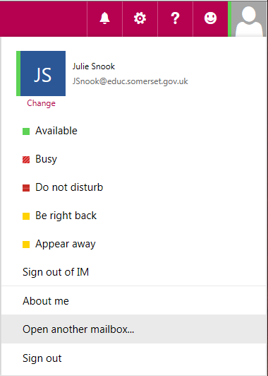  
     
   In the prompt box that displays, type your county treasury number and click **Open**.  
     
   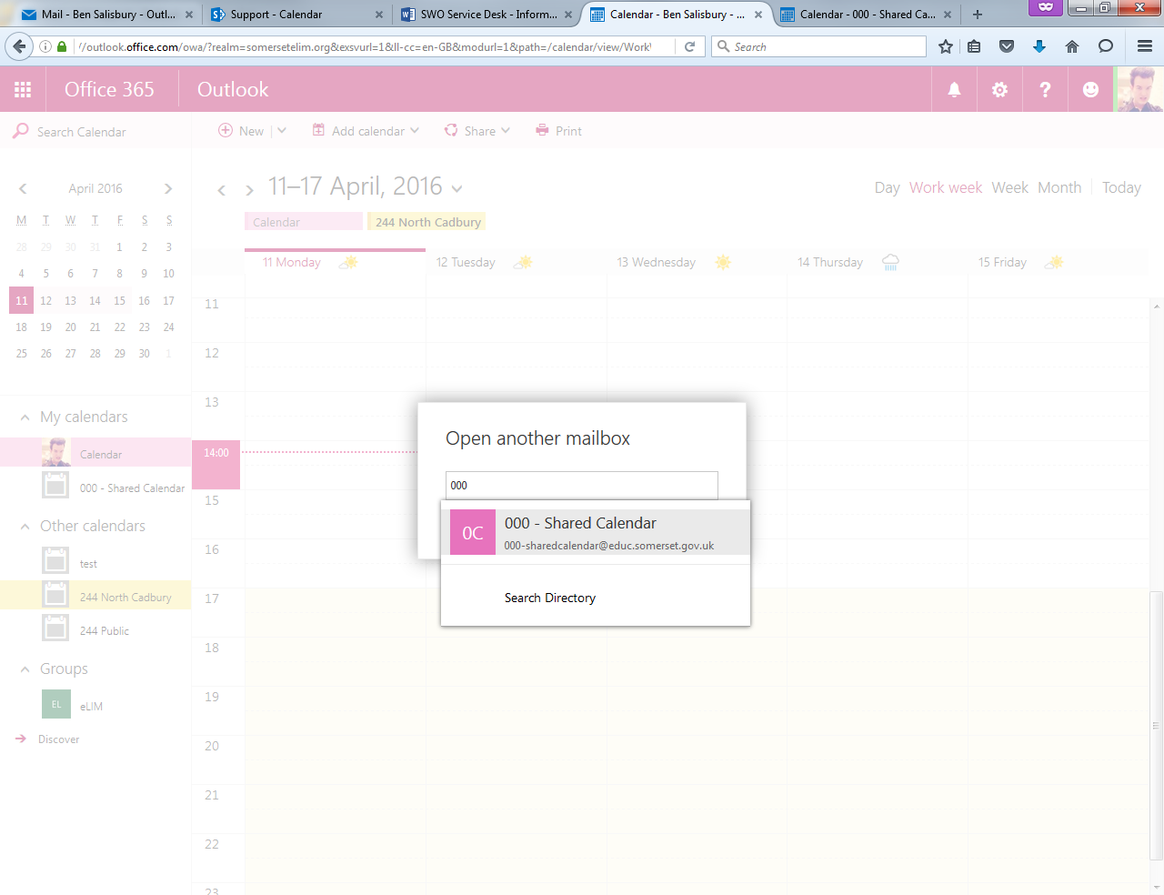 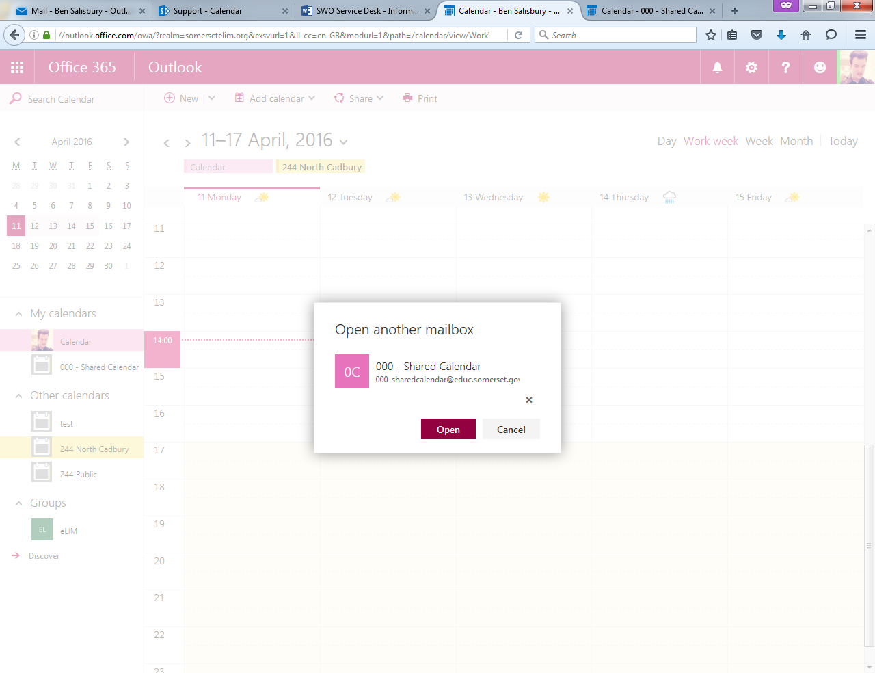  
     
   A new tab will open with “000 – Shared Calendar”.
3. Next, click on the cog wheel in the top right then under **My app settings** select **Calendar**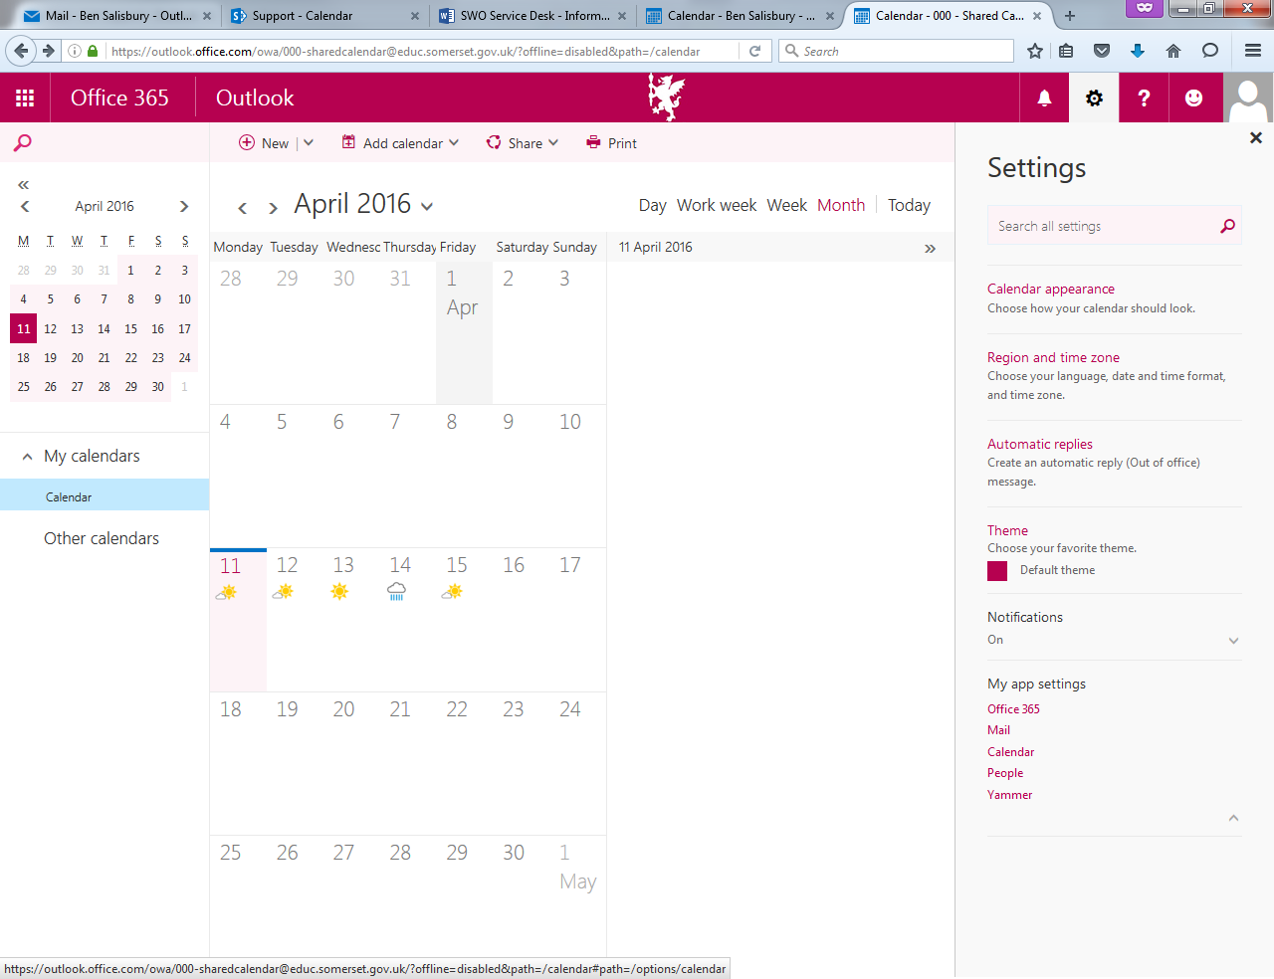  
     
     
     
     
     
     
     
     
     
     
   On the left, Under **Calendar** select **Publish Calendar**  
     
   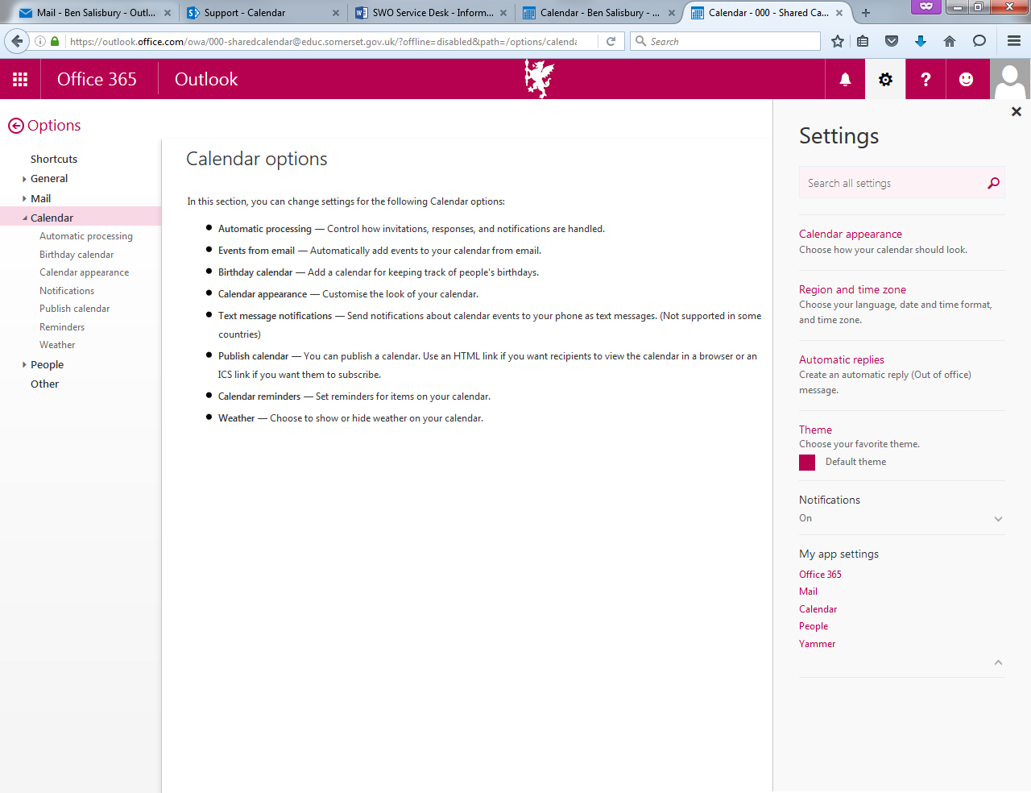  
     
   Under **select permissions,** choose **Full Details** then click Save.  
     
   You will then see two URLs, *HTML* and *ICS*.  
     
   Right click the ICS link and choose **Copy Shortcut**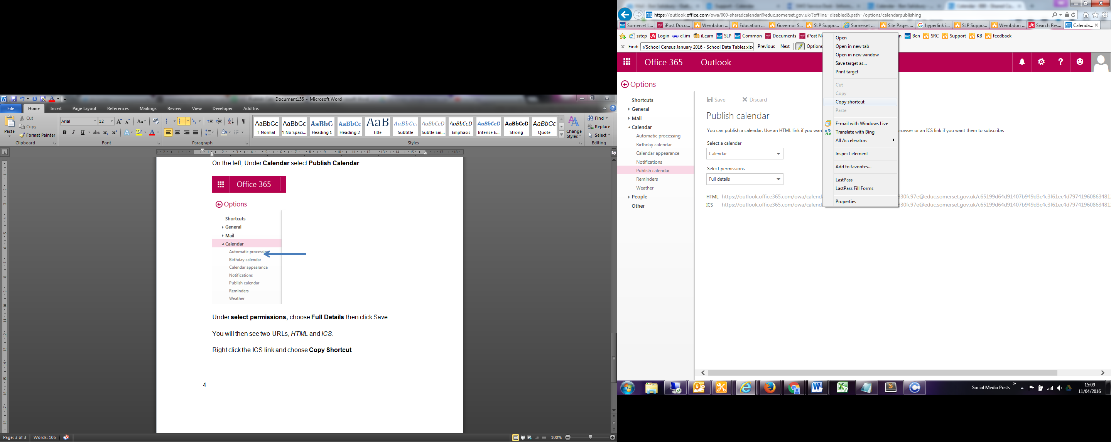Paste this link into an email to an account you can access on the Device you’re hoping to add the calendar too.
4. Open your email on your iPhone/iPad and copy the link you emailed yourself  
     
   Go to **Settings > Mail, Contacts, Calendars > Add Account > Other**Select **Add Subscribed Calendar** and **Paste** the copied link  
     
   Then select **Next** and **Save**